 

INSTITUTE FOR ADVANCED COMPUTING AND SOFTWARE DEVELOPMENT AKURDI, PUNE

Documentation On

**“MART INVENTORY”**

PG-DAC SEP 2022

*Submitted By:*

**Group No: 14**

# PALASH KARDHEKAR 229052

# &

# BHAVESH KUMAR VERMA 229019

**Mrs. Sonali Mongal Mr. Rohit Puranik**

**Project Guide Centre Coordinator**

# Table of Contents

1. Introduction 3

Problem Statement 3

Aim & Objectives 3

1. Overall Description 4

Proposed Methodology 4

Operating Environment 4

Design and Implementation Constraints 5

1. Requirements Specification 6

External Interface Requirements 6

1. System Diagram 7

Activity Diagram 7

Data Flow Diagram 8

Class Diagram 9

Use Case Diagram 10

ER Diagram 11

1. Table Structure 13

Product 13

Product_Location 13

Bill_Details 14

Category 14

Customer_Bill_tbl 15

Customer_Bill_tbl_Product 15

Customer 15

Employee 16

Shopping_Cart 16

Shopping_Cart_tbl_Product 16

Users 16

1. Project Screen Shots 17

Home Page 17

Login Page 18

Registration Page 19

Dash Board 20

Employee List 21

Add Employee 21

Product List 22

Add Product 22

Bill_Details 23

Search Product and add into bill detail 23

Customer List 24

Add Customer 24

1. Conclusion 25

Future Scope 25

1. References 26

**List of Figures**

Figure 1 Admin Activity Diagram 7

Figure 2 Data Flow Diagram 8

Figure 3 Class Diagram 9

Figure 4 Use Case Diagram 10

Figure 5 ER (MySQL Auto Generated) 11

Figure 6 ER Diagram 12

**Introduction:**

# INTRODUCTION.

Mart Inventory is a web application. It provides a platform that will automate various tasks associated with handling product catalog and Execution of proper billing system better organizing the stored information and optimum performance. Helping the business to ensure smooth working of the process that provides the function and features to authenticate and identify the sales person and provide then with easy, intuitive, personalized and user-customizable web-interface for facilitating access to information and services that are of primary relevance and interests to the sales person.

## Problem Statement:

There are many problems found in the todays Inventory system. The problems created in the existing system enforced us to develop the new system which minimize the problem of the existing system. These problems are Now a days overcome by mart inventory system that deals with proper storage of stock details so that proper management of stock along with availability of products would be ensured on required time there by increase in productivity would take place.

## Aims and Objective:

The main purpose of this system, is to reduce the consumption of time during maintaining the records of Inventory. Separate divisions are providing to maintain the records of stocks. Our System also procure an easy way not only to automate all functionalities of a mart, but also to produce bill of purchased products. In other words, our mart Inventory application has, following objectives:

* Simple database is maintained.

* Easy operations for the operator of the system.

* User interfaces are user accommodating and attractive; it takes very less time for the operator to use the system.

*The aim is to provides a platform that will automate various tasks associated with handling product catalog & execute proper billing system.

**Proposed Methodology:**

# OVERALL DESCRIPTION.

The objective of Mart Inventory application is to provide a platform to run a businesses with the ability to computerize, systemize and correlate retail information, this application can gather, store information on inventory, employee and customer information. It allows you to reduce pricing errors and speed up checkouts. Mart Inventory application enables cashiers to process transactions and serve customers efficiently, and allows managers to maintain tight control. It provides features such as Log In of Sales person, manager add new sales person, delete sales person, add product, update product, delete product ,pay bill, store inventory details, product list, employee list, billing details.

This System allows Clients to maintain their products for adding or removing from catalog based on their availability. Manager will be able to review orders history and may able to cancel order within 24 hours, order place. The System will be able to show live Business Operation statistics trends through Customized dashboard for manager/owner. The system will enable to do transactions and produce bills for products.

## Operating Environment:

Server Side:

**Processor:** Intel® Xeon® processor 3500 series

**HDD:** Minimum 500GB Disk Space

**RAM:** Minimum 4GB **OS:** Windows 10, Linux 6 **Database:** MySQL

Client Side (minimum requirement):

**Processor:** Intel Dual Core

**HDD:** Minimum 80GB Disk Space

**RAM:** Minimum 2GB

**OS:** Windows 7, Linux

## Design and Implementation Constraints:

* The application will use JavaScript, jQuery and CSS as main web technologies.
* HTTP and FTP protocols are used as communication protocols. FTP is used to upload the web application in live domain and the client can access it via HTTP protocol.
* Several types of validations make this web application a secured one and SQL Injections can also be prevented.
* Since Mart Inventory is a web-based application, internet connection must be established.
* The Mart Inventory application will be used on PCs and will function via internet or intranet in any web browser.

**External Interface Requirements:**

# Requirements Specification.

User Interfaces:

* + All the users will see the same page when they enter in this website. This page asks the users a username and a password.
  + After being authenticated by correct username and password, user will be redirect to their corresponding profile where they can do various activities.
  + The user interface will be simple and consistence, using terminology commonly understood by intended users of the system. The system will have simple interface, consistence with standard interface, to eliminate need for user training of infrequent users.

Hardware Interfaces:

* + No extra hardware interfaces are needed.
  + The system will use the standard hardware and data communication resources.

This includes, but not limited to, general network connection at the server/hosting site, network server and network management tools.

Application Interfaces:

**Web Browser:**

The system is a web-based application; clients need a modern web browser such as Mozilla Firebox, Internet Explorer, Opera, and Chrome. The computer must have an Internet connection in order to be able to access the system.

Communications Interfaces:

* + This system uses communication resources which includes but not limited to, HTTP protocol for communication with the web browser and web server and TCP/IP network protocol with HTTP protocol.
  + This application will communicate with the database that holds all the booking information. Users can contact with server side through HTTP protocol by means of a function that is called HTTP Service. This function allows the application to use the data retrieved by server to fulfil the request fired by the user.

# System Diagrams.

## Activity Diagram:

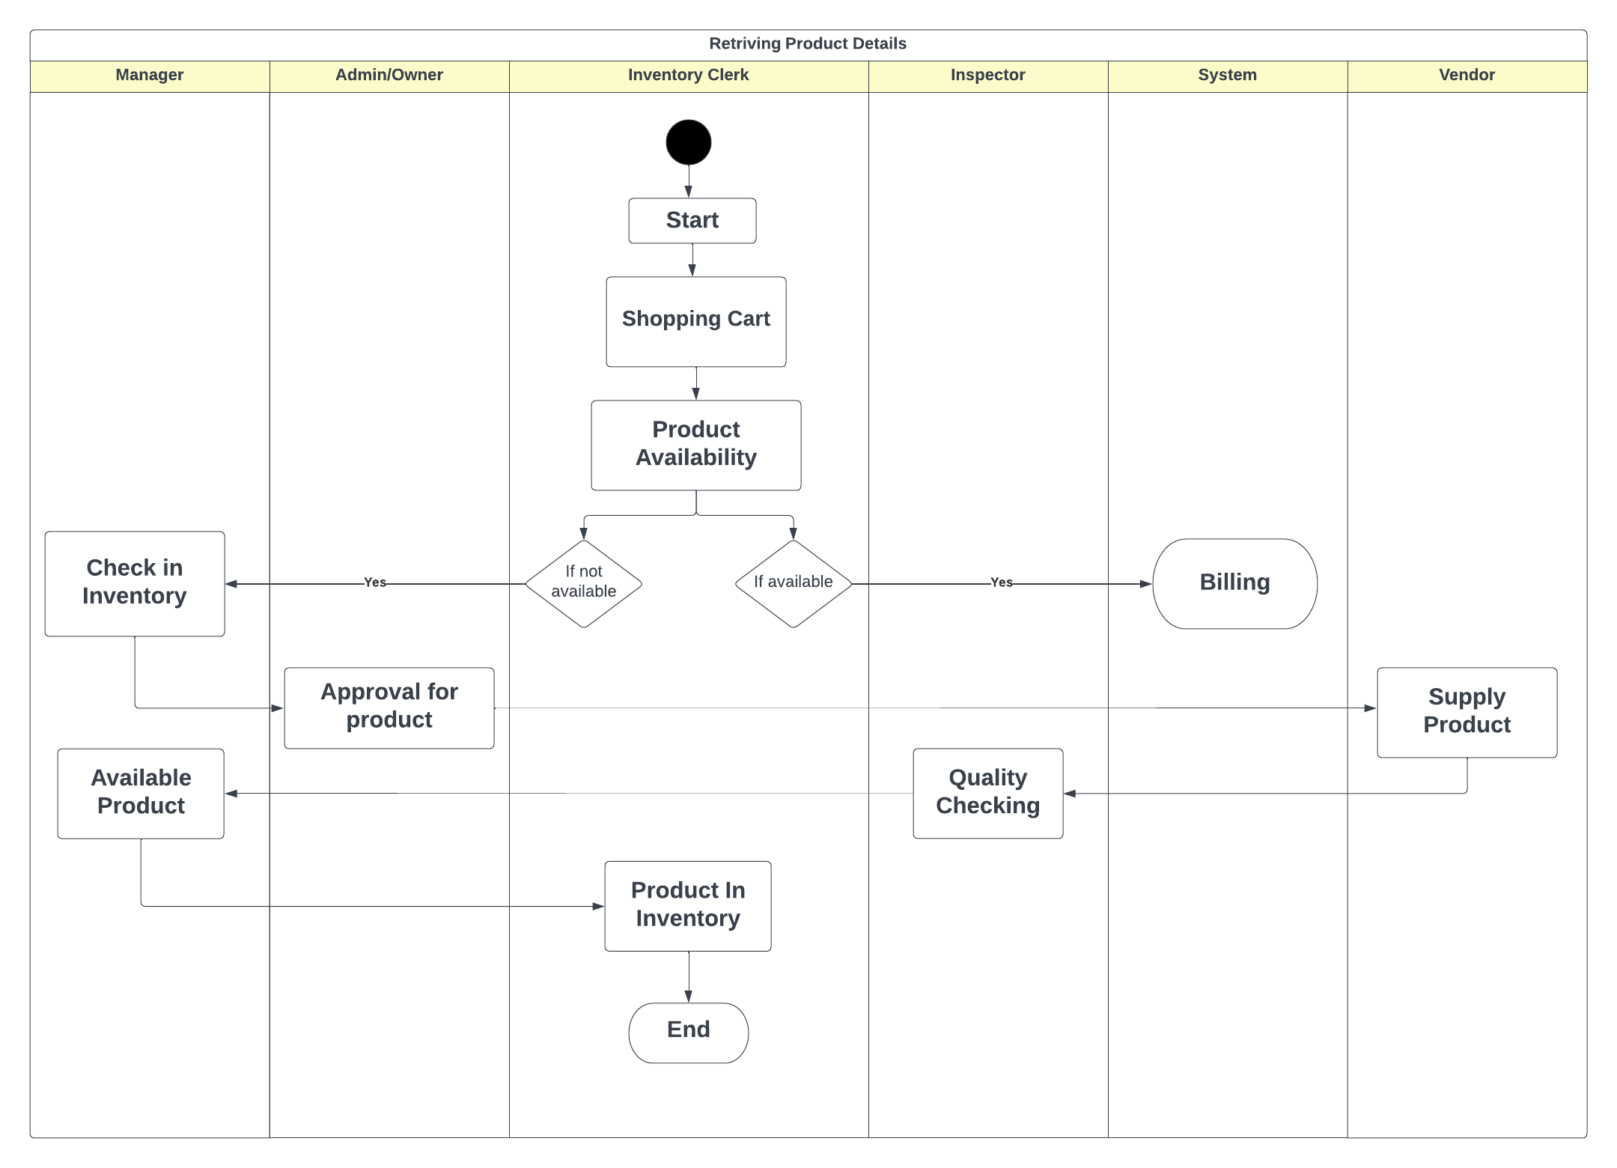

## Data Flow diagram:

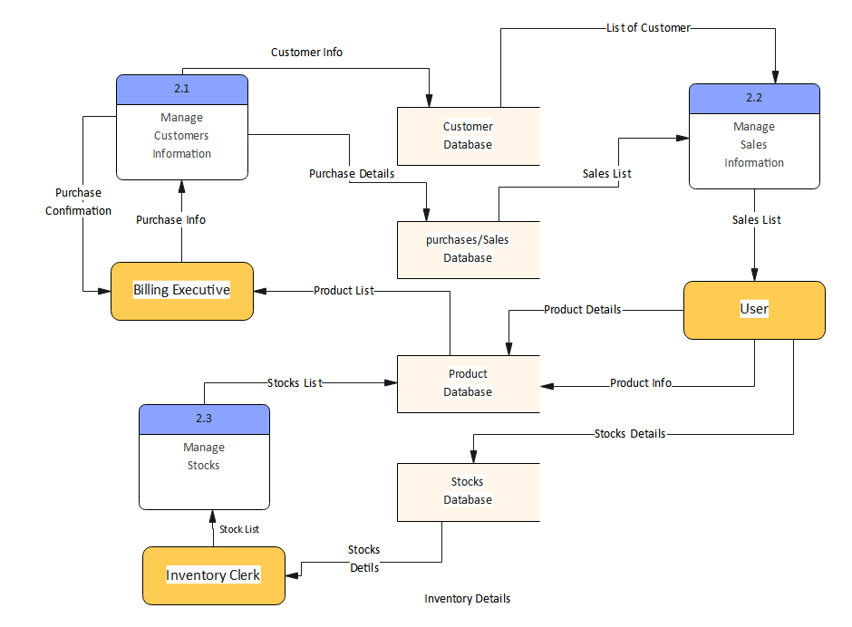

## Class Diagram:

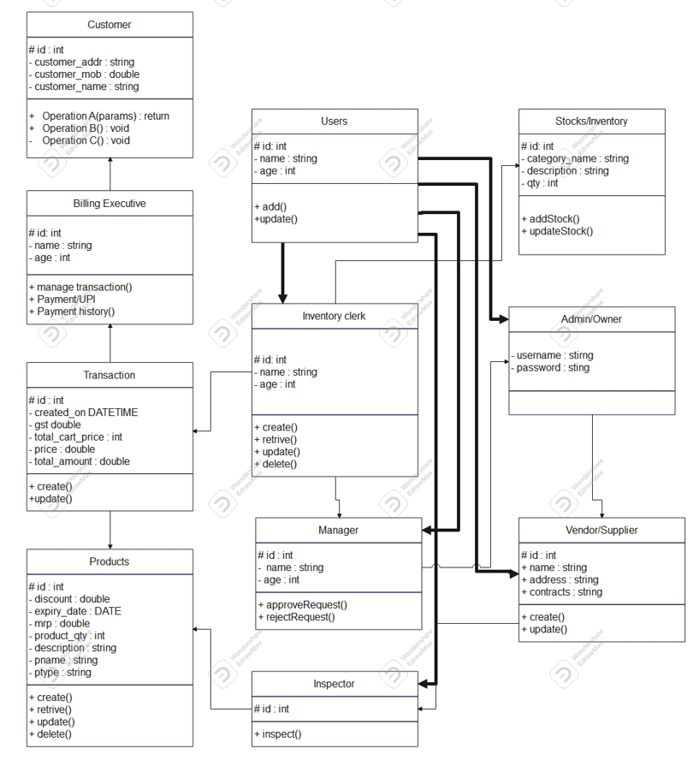

## Use Case Diagram:

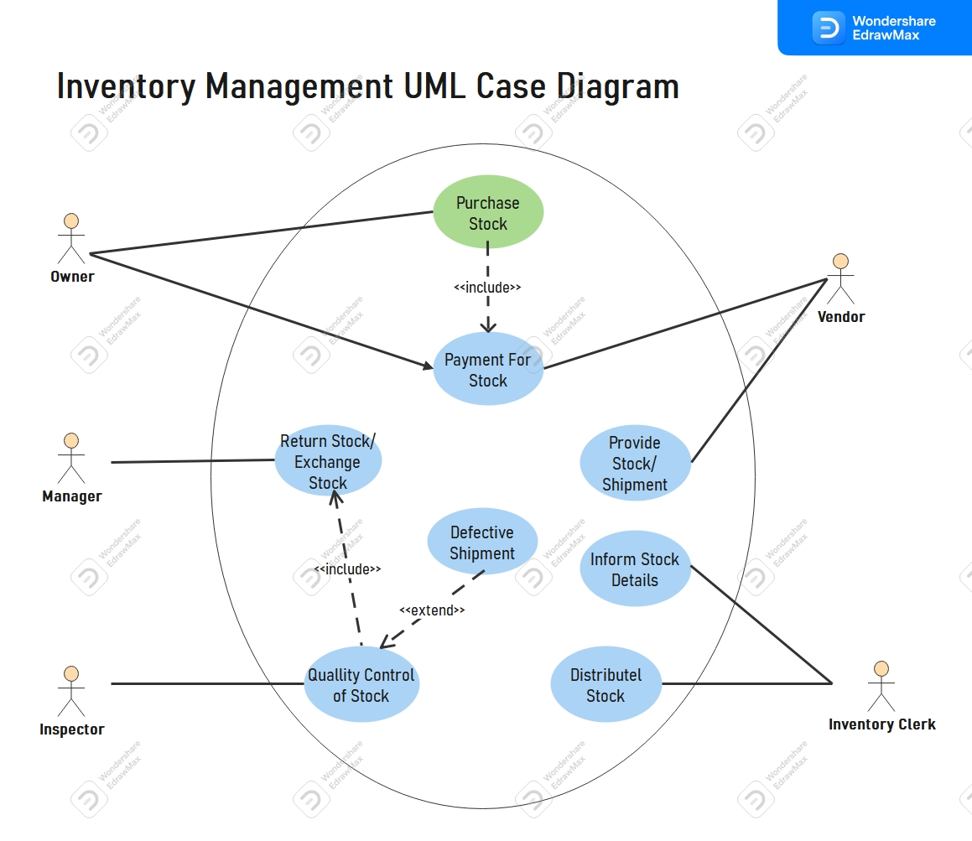

## ER Diagram(System Generated):

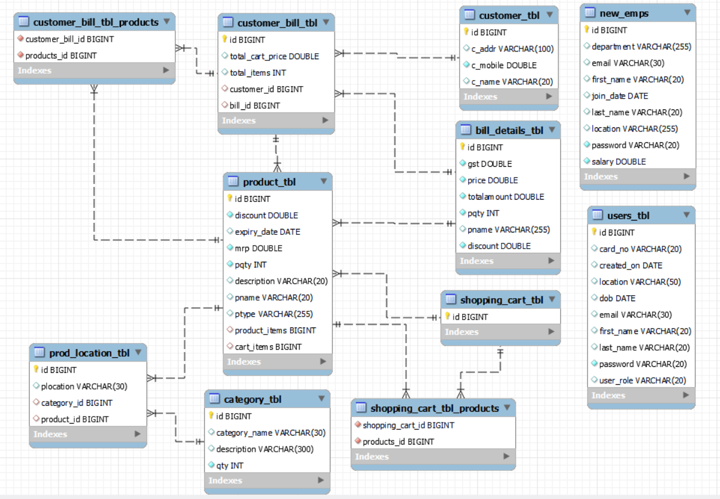

## ER Diagram:

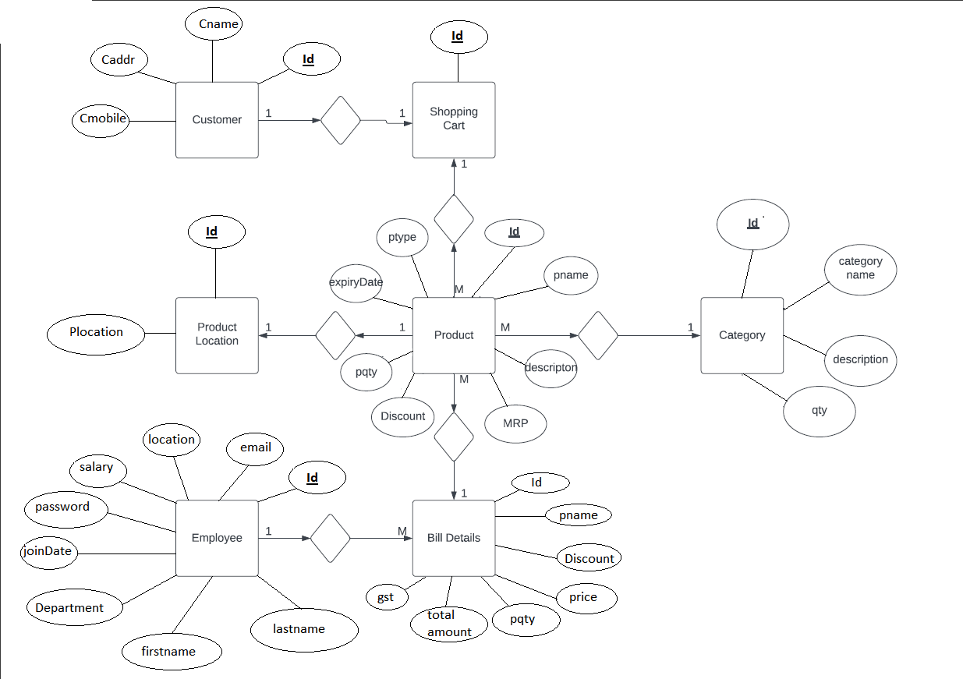

# Table Structure.

* + Product:

|  |  |  |  |  |  |
| --- | --- | --- | --- | --- | --- |
| Field | Type | Null | Key | Default | Extra |
| id | bigint | NO | PRI | NULL | auto_increment |
| pname | varchar(30) | YES |  | NULL |  |
| description | varchar(20) | YES |  | NULL |  |
| discount | double | YES |  | NULL |  |
| mrp | double | YES |  | NULL |  |
| expiry_date | date | YES |  | NULL |  |
| pqty | int | YES |  | NULL |  |
| ptype | varchar(255) | YES |  | NULL |  |
| product_items | bigint | YES | MUL | NULL |  |
| cart_items | bigint | YES | MUL | NULL |  |

* + Product_Location:

|  |  |  |  |  |  |
| --- | --- | --- | --- | --- | --- |
| Field | Type | Null | Key | Default | Extra |
| id | bigint | NO | PRI | NULL | auto_increment |
| productlocation | varchar(30) | YES |  | NULL |  |
| category_id | bigint | YES | MUL | NULL |  |
| product_id | bigint | YES | MUL | NULL |  |

* + Bill_Details:

|  |  |  |  |  |  |
| --- | --- | --- | --- | --- | --- |
| Field | Type | Null | Key | Default | Extra |
| id | int | YES | PRI | NULL | auto_increment |
| gst | double | NO |  | NULL |  |
| price | double | NO |  | NULL |  |
| totalamount | double | NO |  | NULL |  |
| pqty | int | NO |  | NULL |  |
| pname | varchar(255) | YES |  | NULL |  |
| discount | double | NO |  | NULL |  |

* + Category:

|  |  |  |  |  |  |
| --- | --- | --- | --- | --- | --- |
| Field | Type | Null | Key | Default | Extra |
| id | int | NO | PRI | NULL | auto_increment |
| category_name | varchar(30) | YES | UNI | NULL |  |
| description | varchar(300) | YES |  | NULL |  |
| qty | int | NO |  | NULL |  |

* + Customer_Bill_tbl :

|  |  |  |  |  |  |
| --- | --- | --- | --- | --- | --- |
| Field | Type | Null | Key | Default | Extra |
| id | bigint | NO | PRI | NULL | auto_increment |
| total_cart_price | varchar(30) | YES |  | NULL |  |
| total_items | int | YES |  | NULL |  |
| customer_id | bigint | YES | MUL | NULL |  |
| bill_id | bigint | YES | MUL | NULL |  |

* + Customer_Bill_tbl_Products:

|  |  |  |  |  |  |
| --- | --- | --- | --- | --- | --- |
| Field | Type | Null | Key | Default | Extra |
| customer_bill_id | bigint | NO | MUL | NULL |  |
| Product_id | bigint | NO | PRI | NULL |  |

* + Customer:

|  |  |  |  |  |  |
| --- | --- | --- | --- | --- | --- |
| Field | Type | Null | Key | Default | Extra |
| id | bigint | NO | PRI | NULL | auto_increment |
| c_addr | varchar(100) | YES |  | NULL |  |
| c_mobile | double | NO |  | NULL |  |
| c_name | varchar(20) | YES |  | NULL |  |

* + Employee:

|  |  |  |  |  |  |
| --- | --- | --- | --- | --- | --- |
| Field | Type | Null | Key | Default | Extra |
| id | bigint | NO | PRI | NULL | auto_increment |
| department | varchar(255) | YES |  | NULL |  |
| email | varchar(30) | YES | UNI | NULL |  |
| First_name | varchar(20) | YES |  | NULL |  |
| Join_date | date | YES |  | NULL |  |
| Last_name | varchar(20) | YES |  | NULL |  |
| location | varchar(255) | YES |  | NULL |  |
| password | varchar(20) | NO |  | NULL |  |
| salary | double | NO | MUL | NULL |  |

* + Shopping Cart:

|  |  |  |  |  |  |
| --- | --- | --- | --- | --- | --- |
| Field | Type | Null | Key | Default | Extra |
| id | bigint | NO | PRI | NULL | auto_increment |

* + Shopping_Cart_tbl_Products:

|  |  |  |  |  |  |
| --- | --- | --- | --- | --- | --- |
| Field | Type | Null | Key | Default | Extra |
| shopping_cart_id | bigint | NO | MUL | NULL |  |
| products_id | bigint | NO | PRI | NULL |  |

* + User:

|  |  |  |  |  |  |
| --- | --- | --- | --- | --- | --- |
| Field | Type | Null | Key | Default | Extra |
| id | bigint | NO | PRI | NULL | auto_increment |
| card_no | varchar(30) | YES | UNI | NULL |  |
| created_on | date | YES |  | NULL |  |
| location | varchar(50) | YES |  | NULL |  |
| dob | date | YES |  | NULL |  |
| email | varchar(30) | YES | UNI | NULL |  |
| first_name | varchar(20) | YES |  | NULL |  |
| last_name | varchar(20) | YES |  | NULL |  |
| password | varchar(20) | NO |  | NULL NULL |  |
| user_role | varchar(20) | YES |  |  |  |

**Project Screen Shot:**

**Home Page :**

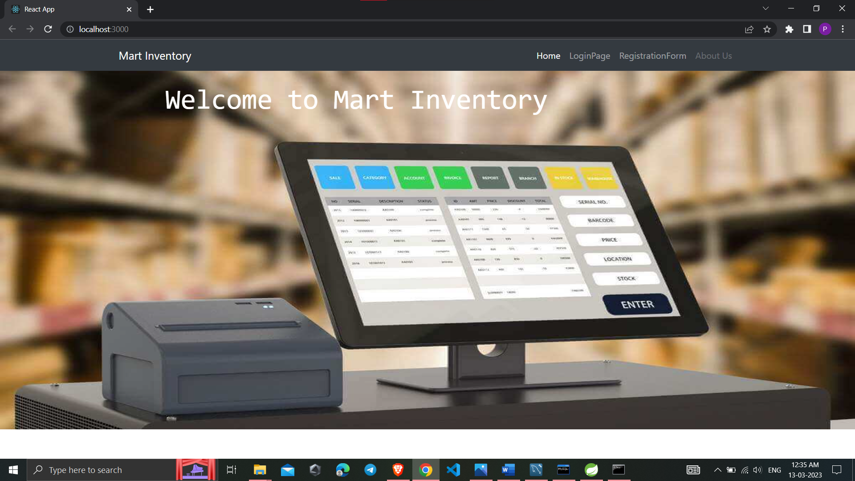

**Login Page :**

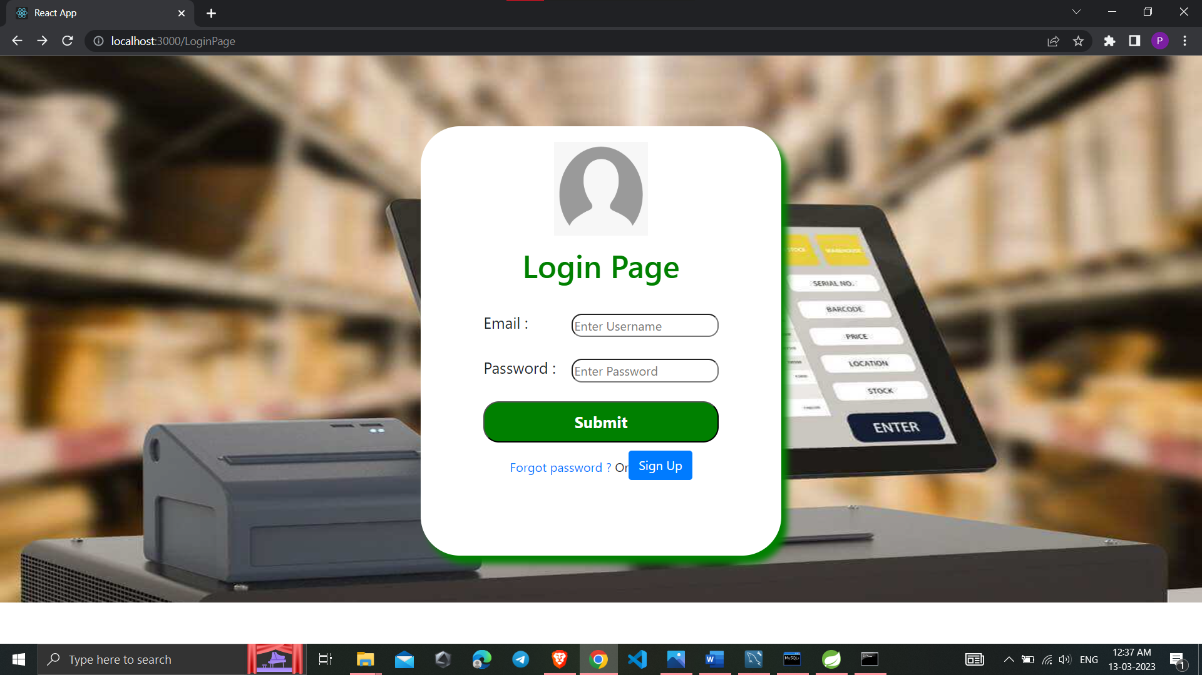

**Registration Page :**

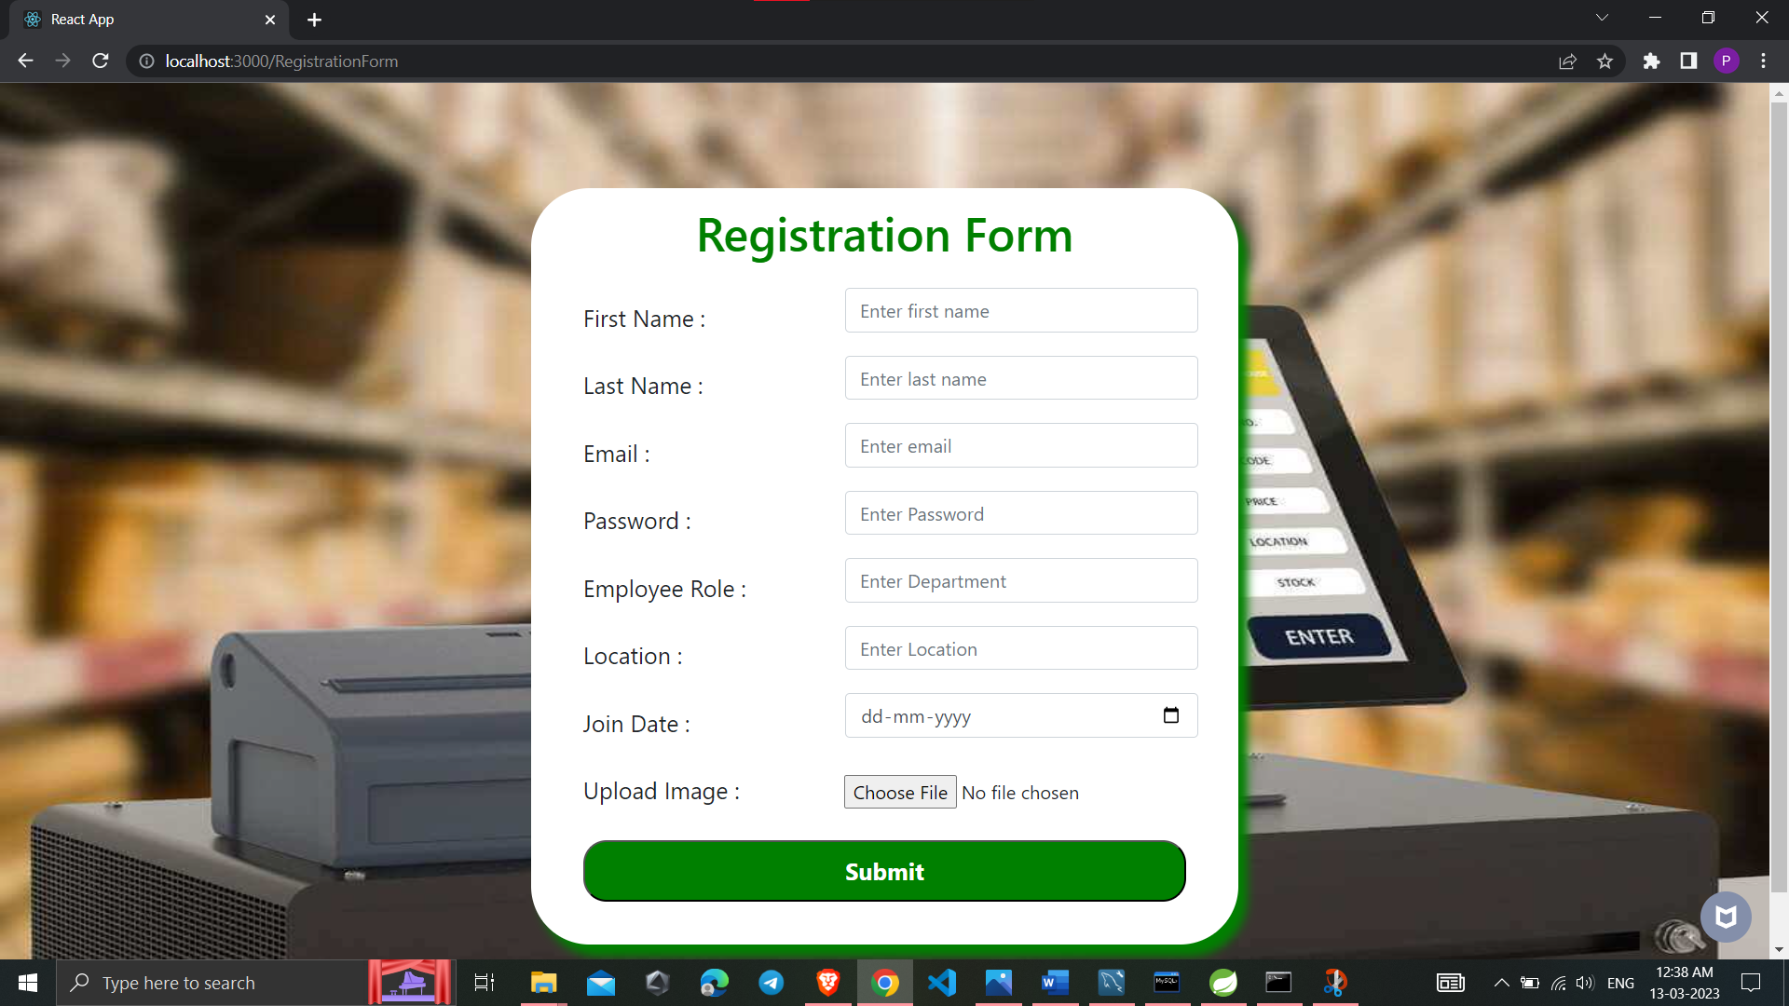

**Dash Board:**

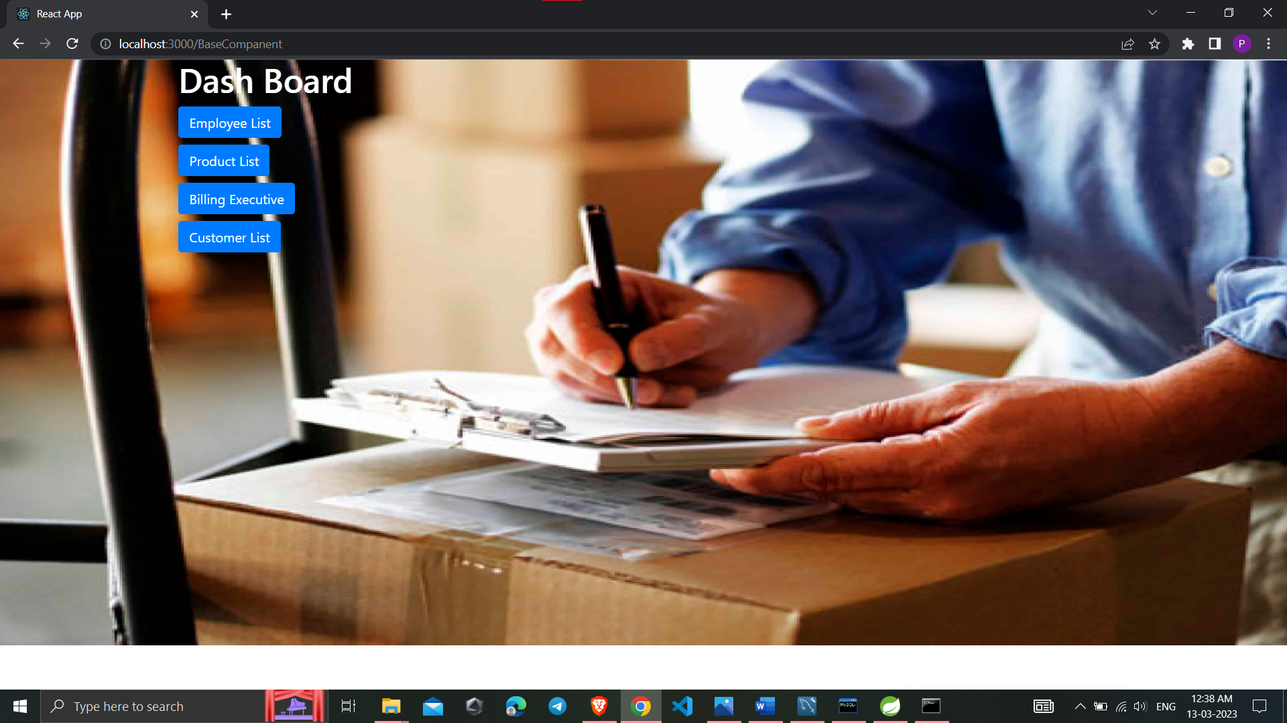

**Employee List :**

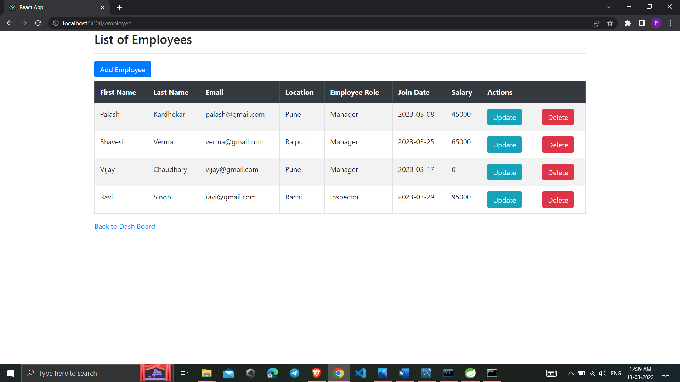

**Add Employee :**

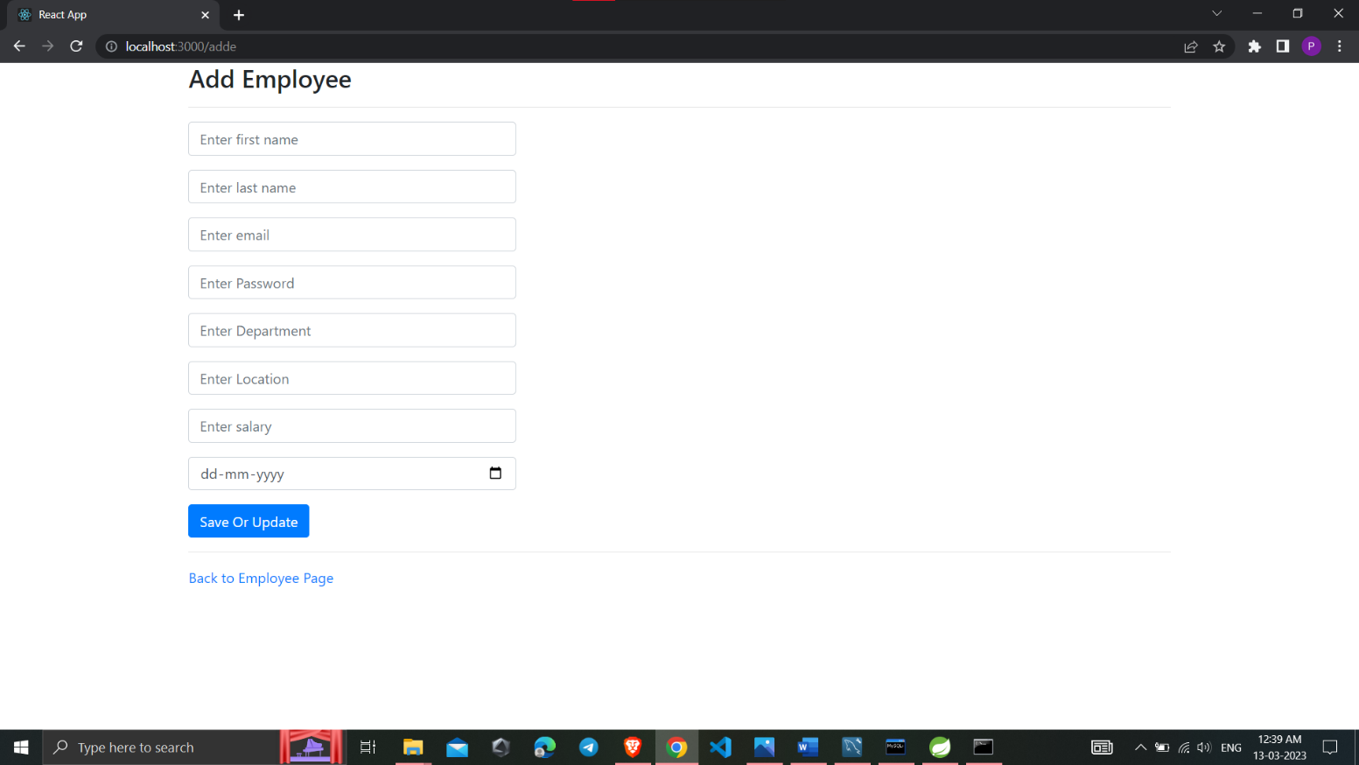

**Product List :**

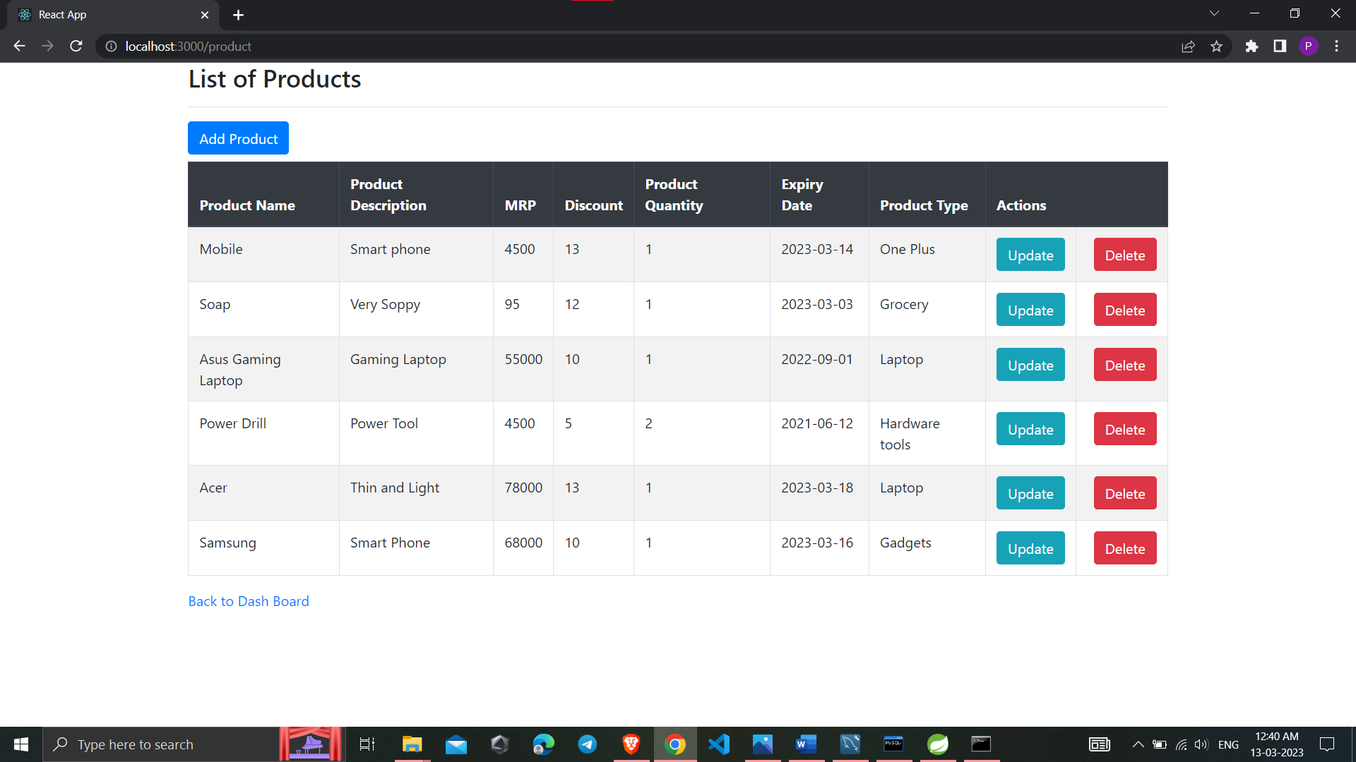

**Add Product :**

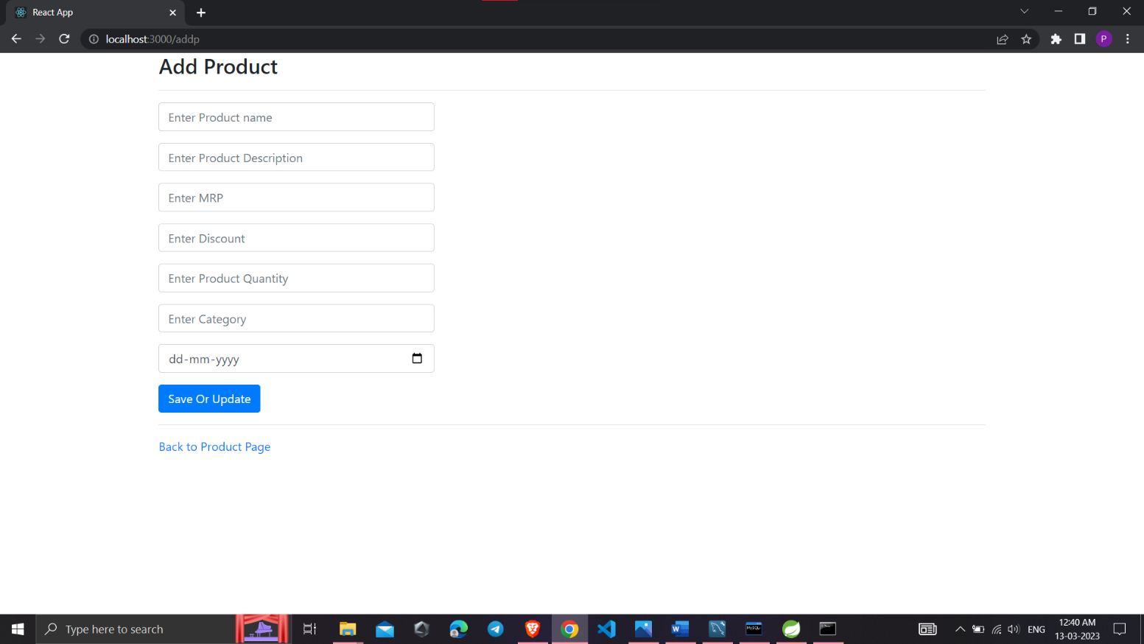

**Bill Details :**

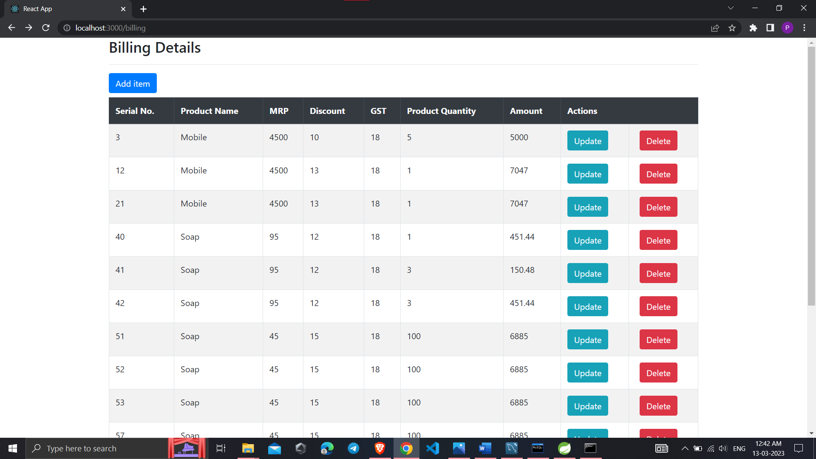

**Search Product and add into Bill Details :**

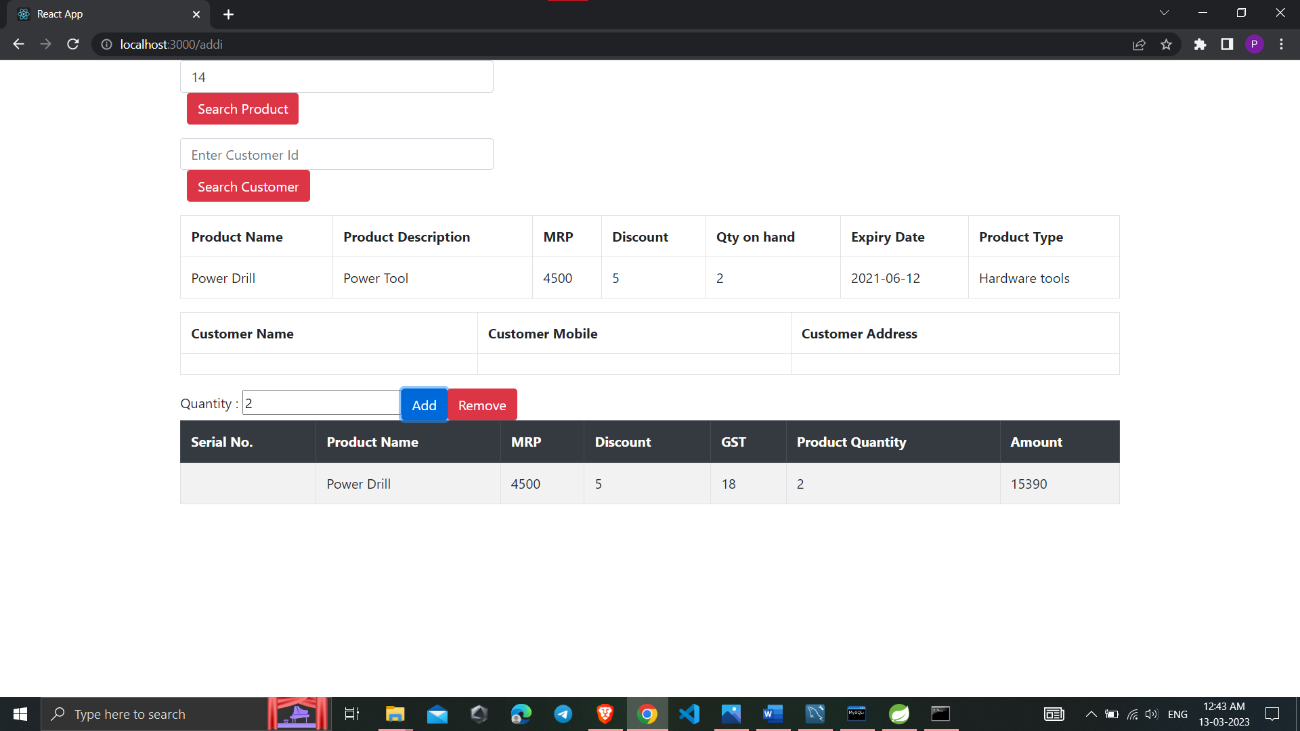

**Customer List :**

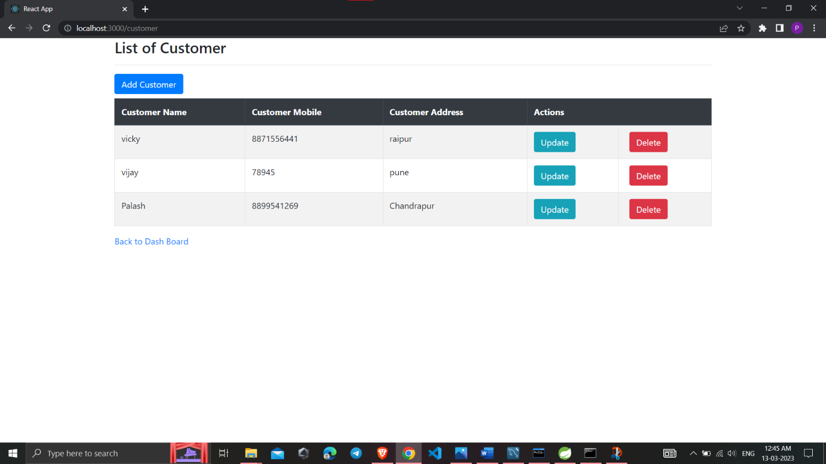

**Add Customer :**

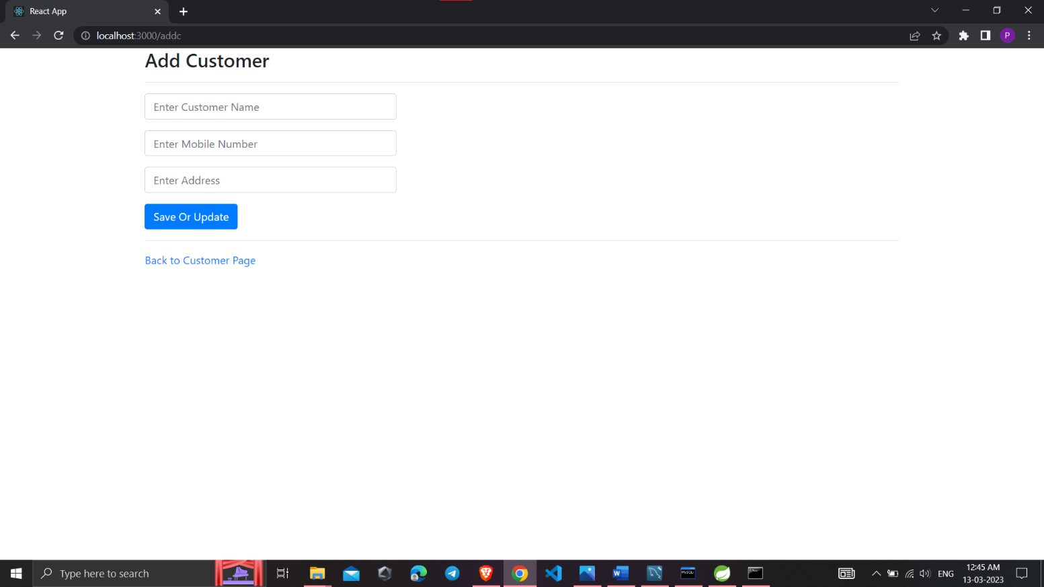

* + **Conclusion:**

# CONCLUSION

This project aid in automating the existing manual system. This is a paperless work. It can be monitored and guarded remotely. It cut down the man power required and provides accurate information. All years together huddled details can be saved and can be accessed at any time. For this reason, the data stored in the repository helps in taking decision by management. So, it is improved to have a Web Based system. All the sales person, manager and owner can get the required information without delay. This system is crucial in the mart and groceries.

## Future Scope:

This project can be enhanced further by adding payable additional specific features such as online feedback system, online product query related to particular products to reduce the extra work of the admin. The software is flexible enough to be modified and implemented as per future requirements. We have tried our best to present this free and user–friendly website to Various Mart owners.

# REFERENCES.

## References:

****<https://bootstrapmade.com/mentor-free-education-bootstrap-them>e <https://www.javatpoint.com/java-mail-api-tutorial>

**<https://javaee.github.io/javaee-spec/javadocs>[/](https://javaee.github.io/javaee-spec/javadocs/) <https://www.w3schools.com/>

* <https://reactjs.org/>

* <https://geeksforgeeks.com/>